Who We Are

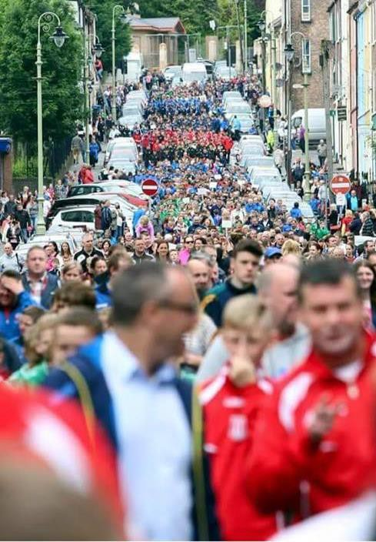
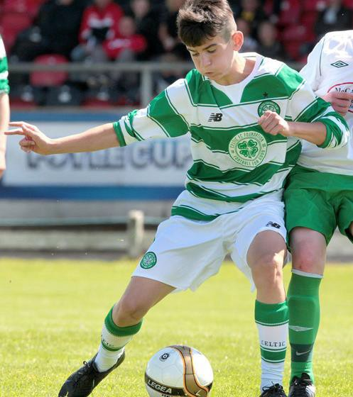

Plu

About Us
The ONeills Foyle Cup Tournament was launched in 1992 with just eight competing teams. To date, the tournament has grown into a six-day festival of football which caters for entries from U8 to U19, with over 450 teams entering annually. The Foyle Cup Tournament has included Senior Ladies and Girl competitions for U9, U11, U13, U15 categories. We also have a very popular Sports with Disability competition.

Tournament Format
Teams are placed in geographically seeded groups and play a series of match against other side in the group. By the end of the group stage, teams are separated into Cup competitions in line with their group standings. Meaning, the best clubs compete for the “Foyle Cup”, and other teams are placed into subsidiary competitions. In doing this, we aim to allow each team to get the same number of games and play at least one match each day for the entire week. Depending on entry demand, it may be necessary for some age groups to play a second game on one of the days.

ONeills Foyle Cup Tournament
July 17 – July 22 2023
Matches are spaced out across the day, allowing spectators to watch up to four games every day. The matches are played at over 38 superb venues in Derry, Strabane, Limavady, Eglinton, Greysteel, Dungiven, Coleraine and throughout counties Tyrone and Donegal. The finals are played at Ryan Mc Bride Brandywell Stadium.

The Foyle Cup Tournament had 455 plus entries across all age groups in 2022. Teams featuring over the years have included Wolves, Sheffield United, Altrincham, Montpellier, Paris St Germain, Norwich City, Slata (Sweden) FD Suomi (Norway), AS Dammartin (France), Everton America (USA), Tampa Bay Rowdies (USA), First Choice Soccer, GPS FC Bayern, Hamilton Academy, Hearts F.C, Partick Thistle, Dunfermline, Kilmarnock, Saint Johnstone, Hibernian FC, Dundee Utd, Werder Bremen, DallasF.C(USA) ,LandsdowneBoys(USA). More and more professional clubs are recognising what the Foyle Cup offers - as are USA entrants!!
In 2023, the Foyle Cup Tournament will run from Monday 17th July – Saturday 22nd July 2023. The entry fee to the tournament is £175 per team. Payment must accompany entry form for tournament.
The Foyle Cup Tournament is administrated by an Organising Committee who are a team of volunteers from the Derry & District Youth Football Association based in Derry.

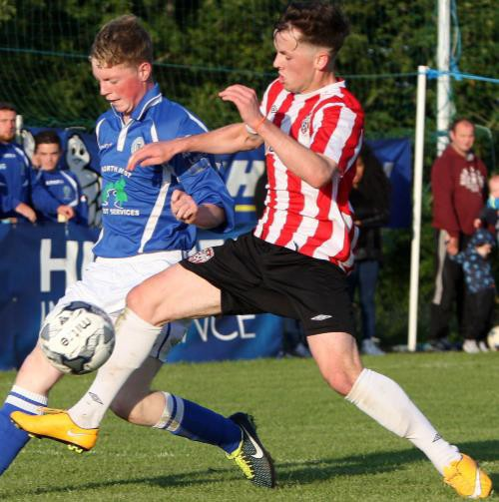

Getting Here
Flights to City of Derry Airport from London, Edinburgh, Glasgow, Manchester, Liverpool, Birmingham.
Derry City is also served by hourly buses from Belfast City Centre, Belfast City Airport and Belfast International Airport.
Alternatively, you can fly to Dublin Airport – the latter having a bus service every 2 hours to Derry City. There are also excellent Ferry links from Great Britain via P&O Ferries and Stena Line.
.If flying from North America, you would ideally want to arrive in Dublin or Belfast. There are a range of airlines doing these routes direct including Aer Lingus, Continental, Delta, Zoom, US Airways & American Airways.
From Europe, check out EasyJet or Jet2 to Belfast or Aer Lingus or Ryanair to Dublin. It is possible to arrive in Shannon but the bus journey to Derry is considerably longer.
Visiting foreign teams will have transport from airport to Derry arranged free, including to and from all games during the week.

Accommodation
If so wished, you can leave your
accommodation worries in our hands.
We have already negotiated great rates and pre- booked rooms with all the local hotels and with Ulster University.
Therefore, we can provide entry teams with a range of accommodation standards.
We allocate accommodation to teams in March once the line-up has been confirmed.
- Hotels (3* / 4*): per person, sharing per night
– from £55 B&B plus Evening Meal
- University: per person, per night in a single room - Bed Breakfast, evening meal from £44 - meals provided at local Martha Vineyard.

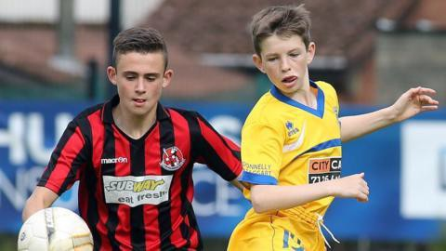
All prices in UK pound sterling and are provisional subject to final quotation from venues.

2022 Foyle Cup Winners

Youth Boys

  - U19 – Derry City FC.
  - U17 – Motherwell FC
  - U16 – Istitute FC
  - U15 – Hibernian FC
  - U14 – Cliftonville FC
  - U13 – Donegal Schoolboys
  - U12 – Maiden City Academy
  - U11 – Ballinamallard Utd FC
  - U10 – Coleraine FC
  - U9 - Ballinamallard Utd. F.C.
  - U8 - Don Boscos FC

Youth Girls Ladies

U9 Linfield Ladies U11 Linfield Ladies
U13 Linfield Ladies, U16 Sion Swifts, Ladies Sion Swifts
Contact Information
For any queries, concerns or questions, we recommend that visitors contact us via Facebook : ONeills Foyle Cup .

Additional communication can be forwarded to Foyle Cup committee:
Contact Tel. 07935924608
email oneillsfoylecup@
gmail.com
CLOSING DATE FOR ENTRIES IS JAN. 31 2023.

2023 Entry Form (Payment Information Attached)

Team Name:
- MINI SOCCER BOYS
AGE GROUP | TICK APPROPRIATELY
7 aside (2015) Under 8 Mini soccer Mon - Fri
7 aside (2014) Under 9 Mini Soccer Mon - Fri
7 aside (2013) Under 10 Mini Soccer Mon - Fri
9 aside (2012) Under 11 Mini Soccer Mon - Fri

(2012) Under 11 Mini soccer Mon - Fri
 | 0

GIRLS / LADIES
(2014) Under 9 Mini Soccer 7 a side Mon - Weds
(2012) Under 11 Mini Soccer 7 a side Mon - Weds
(2010) Under 13 9 a side Mon - Weds
(2008) Under 15 11 a side Mon - Thurs

Senior Ladies 11 a side Mon - Thurs

3. BOYS / YOUTH

These are pre - season matches so 11 A SIDE
AGE GROUP | TICK APPROPRIATELY
(2011) Under 12 11 A SIDE Mon - Sat
(2010) Under 13 11A SIDE Mon - Fri
(2009) Under 14 11 A SIDE Tues - Sat
(2008) Under 15 11 A SIDE Mon - Fri
(2007) Under 16 11 A SIDE Tues - Sat
(2006) Under 17 11 A SIDE Mon - Fri
(2004) Under 19 11 A SIDE Mon - Fri

Boys ?youth
Contact Information
SPORTS DISABILITY AGE GROUP TICK APPROPRIATELY
One Day Event 7 v7

Primary Contact Name: Primary Contact Telephone: Primary Contact E-Mail Address:

Primary Contact Address:

Postcode:

Closing date for entries is Jan. 31 2023.
Entry Form Payment
The Entry Form payment is £175 per team.
Girls mini soccer at U9/11/13 entry fee is £100.

Payment will be refunded to non-successful applicants.
No entry form will be considered unless entry fee is received within 7 days.
The 2023 Entry Form can be emailed to:

oneillsfoylecup@gmail.com

If you wish to pay by Bacs transfer,
see bank details below.

Ulster Bank Da Vinci Complex Culmore Road Derry

Account Name: Derry & District Youth FA

Sort Code: 98 09 80 Account No: 43900247

IBAN : GB 10ULSB98098043900247 IBAN BIC : ULSBGB2B

Sponsors
