A Derry Welcome..  The O’Neills Foyle Cup Tournament was launched in 1992 with just eight competing teams. To date, the tournament has grown into a six-day festival of football which caters for entries from U8 to U19, with over 950 teams entering annually. The Foyle Cup Tournament has included Girls’ competitions from U9 to U17. We also have a very popular Sports with Disability competition.  Tournament Format  Teams are placed into geographically seeded groups and play a series of matches against each other in group stages. By the end of the group stage,teams are separated into Cup competitions in line with their group standings. Meaning, the best performing clubs will compete for the ‘Foyle Cup’ and other teams are placed into subsidary competitions. In doing this, we aim to allow each team to get the same number of games and play at least one match per day for the entire week. Depending on the entry demand, it may be necessary for some age groups to play a second game on one of these days.  Matches are spaced out across the day, allowing spectators to watch up to four games every day. The matches are played at over sixty superb venues in Derry, Strabane, Limavady, Dungiven, Coleraine and throughout counties Tyrone and Donegal. The finals are staged at the re-nowned Ryan McBride Brandywell Stadium. |  | 2025 Recap  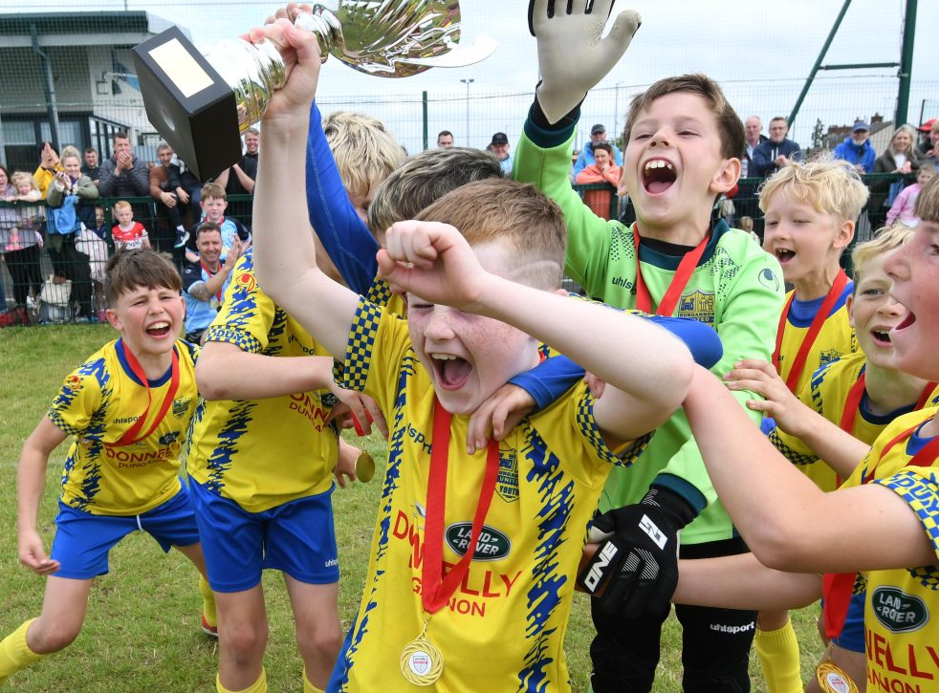  The 2025 Foyle Cup had 950 entries across all age groups. Teams featuring in previous years include: Wolves, Sheffield United, Altrincham, Montpellier, Paris St Germain, Norwich City, Everton America (USA), Celtic FC, Partick Thistle, Kilmarnock, Hearts FC, Bayern Hamilton Academy, FP Suomi (Norway), Slata FD (Sweden), Dallas F.C. (USA) – to name a few! More professional clubs are recognising what the Foyle Cup has to offer and our participants are coming from all over the globe.  In 2026, the Foyle Cup Tournament will run from Monday 20 July – Saturday 25 July 2026. The entry fee to the tournament is £175 per team and must accompany your entry form.  The Foyle Cup Tournament is administrated by an Organising Committee who are a team of volunteers from the Derry & District Youth Football Association based in Derry.  Getting Here  2025 Foyle Cup Winners  Boys Section  - U19 – Carndonagh FC  - U17 – Derry City FC  - U16 – Club Mercedarios (Spain)  - U15 – Aquinas FC  - U14 – Partick Thistle FC  - U13 – Donegal Underage League  - U12 – Glenavon FC  - U12 (9v9) – Enniskillen Town  - U11 – Ballinamallard United  - U10 – Core Soccer Academy  - U9 - Dungannon United  - U8 – Dungannon United  Girls Section  - U17 – Derry City Ladies  - U15 – Larne FC  - U14 – Sion Ladies Flames  - U13 – Lisbellaw United  - U12 – Donegal Ladies  - U11 – Lisbellaw United  - U10 – Linfield FC  - U9 – Linfield FC  Accommodation  We encourage most teams to arrange their own accommodation however we are here to assist where necessary. The Tournament has negotiated great rates with local hotels (3* and 4*). Details of hotel email addresses can be forwarded on enquiry.  Teams wishing to stay at the Ulster University Student Accommodation should contact us for more details.  We hope to have 500 beds available at their Magee Campus in Derry and a further 300 available in Coleraine.  Prices  - Hotels (3*/4*): per person, sharing per night – from £75 includes bed, breakfast plus evening meal.  - University: per person, per night in a single room – bed, breakfast and evening meal from £60 – meals provided at local Martha’s Vineyard restaurant.  All prices are in £ sterling and are provisional subject to final quotation from venues.  Derry is situated in the North West of Ireland and has comprehensive travel networks – via road, air and sea. Derry has its own airport and welcomes flights direct from London,Edinburgh, Glasgow,Manchester,Liverpool, Birmingham.  Derry is also served by hourly buses from Belfast City Centre, Belfast Airports and Dublin.  Ferry links from Great Britain are daily with well-known operators Stenaline and P&O Ferries able to provide services from Scotland, mainland England and Wales.  If flying from North America, you would ideally want to arrive in Dublin or Belfast International Airports. There are a range of airlines who have direct routes to these airports including Aer Lingus.  From Europe, check out well-known providers such as EasyJet, Ryanair and Jet2.  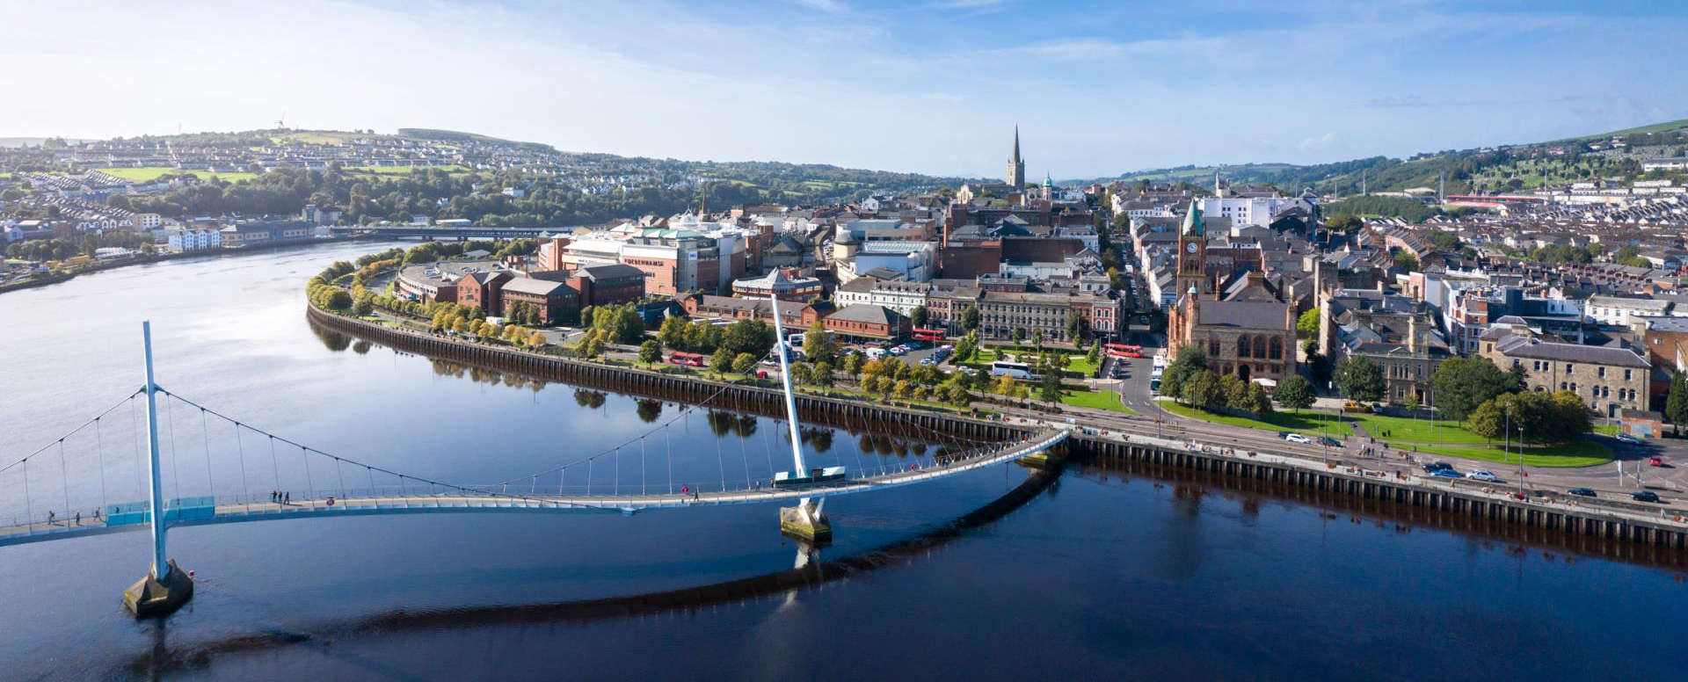    Visiting foreign teams will have transport from their arriving Airport to Derry for free. This transport will include your transportation to and from game venues during the week of the tournament – courtesy of the Foyle Cup Tournament.  Boys Section — 11aside Soccer  Girls Section — All Competitions |  | 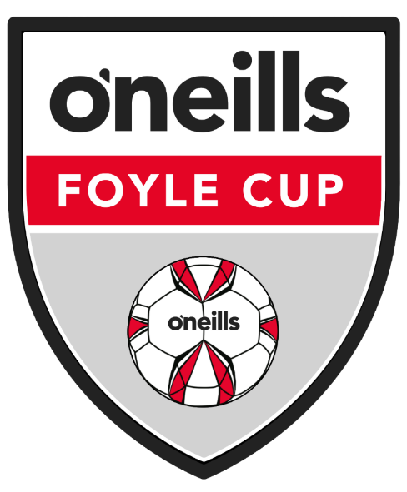  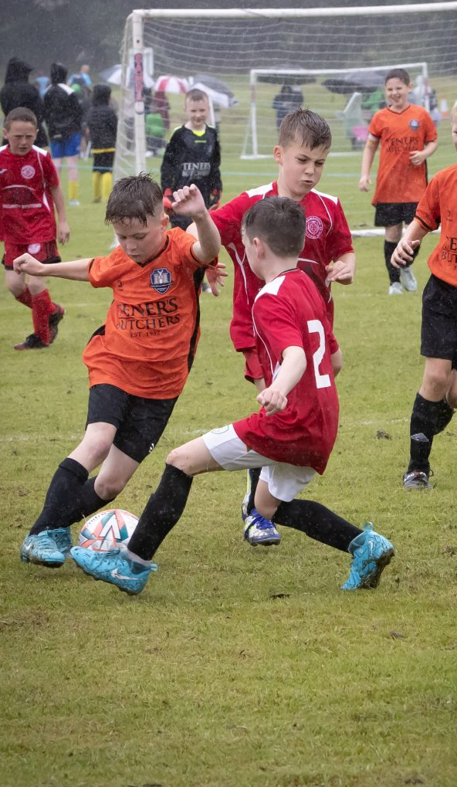  O’Neills Foyle Cup Tournament  20 July – 25 July 2026  Derry~Londonderry
  Format | Age Category | Days / Teams | Please Tick to Confirm Entry
  11aside (2014) | Under 12 | Mon-Sat  (24 Teams)
  11aside (2013) | Under 13  Premier Division | Mon-Sat  (64 Teams)
  11aside (2013) | Under 13  Championship | Mon-Sat  (64 Teams)
  11aside (2012) | Under 14  Premier Division | Mon-Sat  (64 Teams)
  11aside (2012) | Under 14  Championship | Mon-Sat  (64 Teams)
  11aside (2011) | Under 15  Premier Division | Mon-Sat  (32 Teams)
  11aside (2011) | Under 15  Championship | Mon-Sat  (32 Teams)
  11aside (2010) | Under 16 | Mon-Sat  (24 Teams)
  11aside (2009) | Under 17 | Mon-Friday  (24 Teams)
  11aside (2007) | Under 19 | Mon-Friday  (16 Teams)
  Format | Age Category | Days / Teams | Please Tick to Confirm Entry
  7aside (2017) | Under 9 Mini | Mon-Friday  (24 Teams)
  7aside (2016) | Under 10 Mini | Mon-Friday  (24 Teams)
  7aside (2015) | Under 11 Mini | Mon-Friday  (24 Teams)
  9aside (2014) | Under 12 Mini | Mon-Friday  (24 Teams)
  9aside (2013) | Under 13 Mini | Mon-Friday  (32 Teams)
  11aside (2012) | Under 14 Ladies | Mon-Friday  (24 Teams)
  11aside (2011) | Under 15 Ladies | Mon-Friday  (24 Teams)
  11aside (2009) | Under 17 Ladies | Mon-Friday  (16 Teams)
Important Information Please print and complete this entry form. All forms may be emailed to oneillsfoylecup@gmail.com  Entry Fee for all Age groups of £175.00 Sterling Cheques payable to Foyle Cup can be posted to:  Foyle Cup, c/o 8 Papworth Ave, Derry City. BT488PT  BACS Transfer Details if preferred  - Account Name: Derry & District Youth FA  - Sortcode: 98 09 80 | Account No: 43900247  - IBAN: GB 10ULSB98098043900247  - IBAN BIC: ULSBGB2B |  |  |  | Stree Address  City, ST ZIP Code  Phone Number  Fax Number
Boys Section — Mini Soccer
Format | Age Category | Days / Teams | Please Tick to Confirm Entry
7aside (2018) | Under 8 Mini | Mon-Friday  (72 Teams)
7aside (2017) | Under 9 Mini | Mon-Friday  (72 Teams)
7aside (2016) | Under 10 Mini | Mon-Friday  (72 Teams)
9aside (2015) | Under 11 Mini | Mon-Friday  (96 Teams)
9aside (2014) | Under 12 Mini | Mon-Friday  (56 Teams)

Contact Details

Team Responsible Person: ___________________ Team Email:______________________
Team Contact No: ______________________ Closing Date for entries is January 31st
2026 Entry Form

Team Name: _________________________
League Affiliation: ______________________
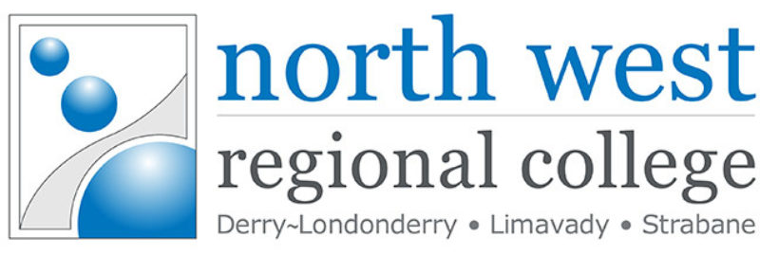     |  |  |  | Our Sponsors    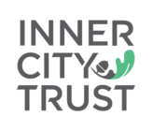
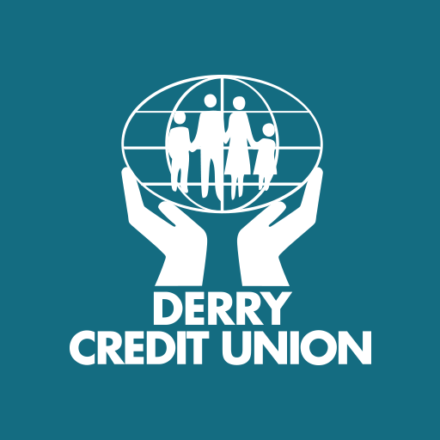  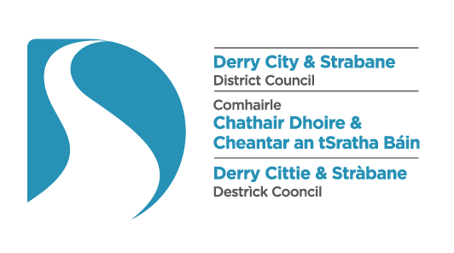 |  |  |  |  | 
 |  |  |  |  | 