A Warm Derry Welcome  The O’Neills Foyle Cup Tournament was launched in 1992 with just eight competing teams. To date, the tournament has grown into a six-day football festival which caters for entries from U8 to U19, with over 950 teams entering annually. The Foyle Cup Tournament has included Girls competitions from U9 to U17. We also have a very popular Sports with Disability competition.  Tournament Format  Teams are placed into geographically seeded groups and play a series of matches against each other in group stages. By the end of the group stage, teams are separated into Cup competitions in line with their group standings. This means the best performing clubs will compete for the ‘Foyle Cup’ and other teams are placed into subsidiary competitions. In doing this, we aim to allow each team to get the same number of matches and play at least one match per day for the entire week. Depending on the entry demand, it may be necessary for some age groups to play a second game on one of these days.  Matches are spaced out across the day, allowing spectators to watch up to four games every day. The matches are played at more than 60 superb venues in Derry, Strabane, Limavady, Dungiven, Coleraine and throughout counties Tyrone and Donegal. | 2026 Recap  The 2026 Foyle Cup had an impressive 1,013 entries across all age groups. Teams featuring in previous years include: Wolves, Sheffield United, Celtic FC, Altrincham, Montpellier, Paris St Germain, Norwich City, Everton America (USA), Partick Thistle, Kilmarnock, Hearts FC, Bayern Hamilton Academy, FP Suomi (Norway), Slata FD (Sweden), Dallas F.C. (USA) – to name a few! More professional clubs recognise what the Foyle Cup has to offer, and our participants come from all over the globe.  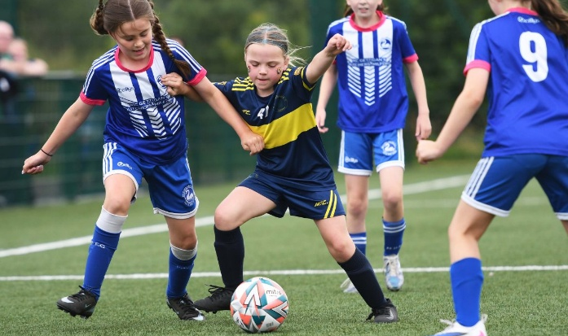  The Tournament will run from Monday 26 July – Saturday 31 July 2027. The entry fee to the tournament is £175 per team.  The Foyle Cup Tournament is administered by an Organising Committee who are a team of volunteers from the Derry & District Youth Football Association based in Derry. | 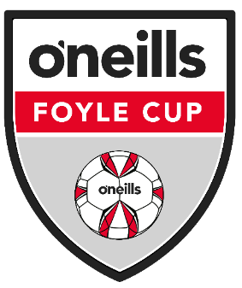    O’Neills Foyle Cup Tournament  26 July – 31 July 2027  Derry~Londonderry

Accommodation  We encourage most teams to arrange their own accommodation however we are here to assist where necessary. The Tournament has negotiated great rates with local hotels (3-star and 4-star). Details of hotel email addresses can be forwarded on enquiry.  Teams wishing to stay at the Ulster University Student Accommodation should contact us for more details.  Prices  - Hotels (3-star/4-star): per person, sharing per night – from £70. Includes bed, breakfast plus evening meal.  - University: per person, per night in a single room – from £60. Includes bed, breakfast and evening meal. Meals provided at local Brunswick Moviebowl restaurant.  All prices are in £ sterling and are provisional subject to final quotation from venues. | Getting Here  Derry is situated in the North West of Ireland and has comprehensive travel networks – via road, rail, air and sea. Derry has its own Airport and welcomes flights direct from London, Edinburgh, Glasgow, Manchester, Liverpool and Birmingham.  Derry is also served hourly by rail and bus networks from Belfast City Centre, Belfast Airports and Dublin.  Ferry links from Great Britain are daily with well-known operators Stena Line and P&O Ferries able to provide services from Scotland, England and Wales.  If flying from North America, you would ideally want to arrive at Dublin or Belfast International Airports. There are a range of airlines who have direct routes to these airports including Aer Lingus. From Europe, check out well-known providers such as easyJet, Ryanair and Jet2.  Visiting teams will have transport from their arriving Airport to Derry for free. This transport will include your transportation to and from game venues during the week of the tournament – courtesy of the Foyle Cup Tournament. | 2026 Foyle Cup Winners  Boys Section  - U19 – Dergview FC  - U17 – Maximum Performance Academy  - U16 – Dundee United  - U15 (P) – Donegal Underage League  - U15 (C) – Immaculata FC  - U14 (P) – FDS Finalnd  - U14 (C) – Altrincham FC  - U13 (P) – Partick Thistle FC  - U13 (C) – Illistrin FC  - U12 – Maiden City Soccer  - U12 (9v9) – Lisdrum Youth  - U11 – Glentoran FC  - U10 – Strathroy Harps  - U9 - Dungannon United  - U8 – Portstewart FC  Girls Section  - U17 – Derry City FC Colts  - U15 – Donegal Ladies  - U14 – Donegal Girls  - U13 – Tristar FC  - U12 – Eglinton Eagles  - U11 – Tummery Athletic  - U10 – Magherafelt Sky Blues  - U9 – Linfield FC
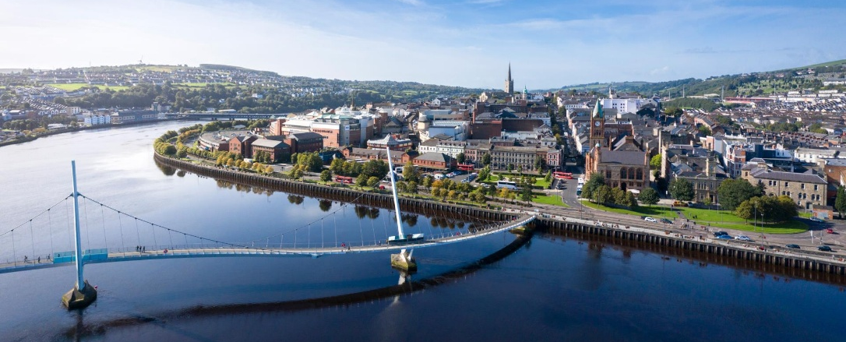
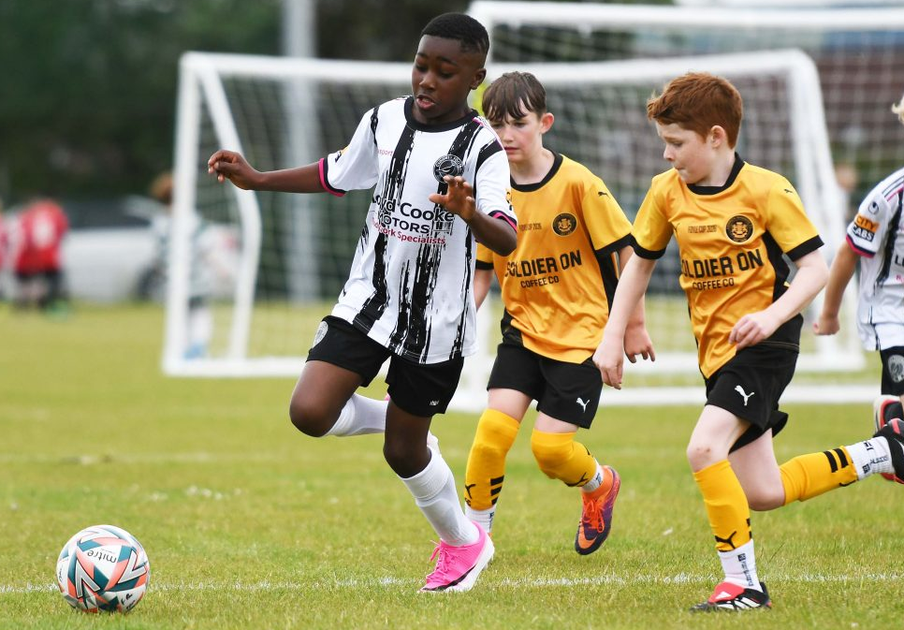
  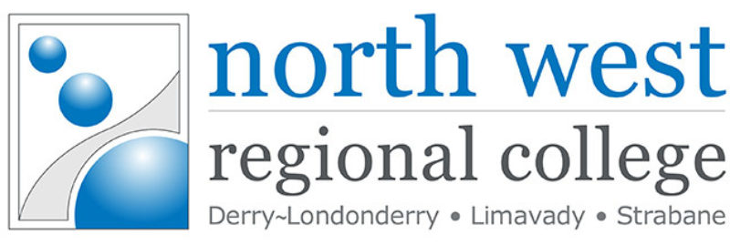    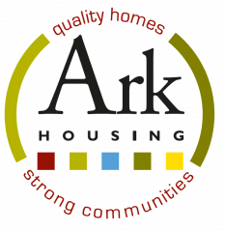   |  |  |  |   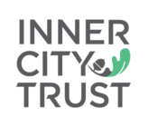  Our Sponsors  
 |  | 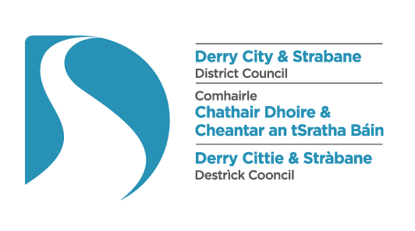



2027 Entry Form
Please tick every competition your club wishes to enter.

Team Name: Click or tap here to enter text. Club Secretary: Click or tap here to enter text.
League Affiliation: Click or tap here to enter text. Contact Email: Click or tap here to enter text. Contact No: Click or tap here to enter text.
Girls Section — All Competitions
Boys Section — 11aside
Format | Age Category | Days / Teams | Tick to Confirm Entry
7aside (2018) | Under 9 Mini | Mon-Friday  (24 Teams) | ☐
7aside (2017) | Under 10 Mini | Mon-Friday  (24 Teams) | ☐
7aside (2016) | Under 11 Mini | Mon-Friday  (24 Teams) | ☐
9aside (2015) | Under 12 Mini | Mon-Friday  (24 Teams) | ☐
11aside (2014) | Under 13 Mini | Mon-Friday  (32 Teams) | ☐
11aside (2013) | Under 14 Ladies | Mon-Friday  (24 Teams) | ☐
11aside (2012) | Under 15 Ladies | Mon-Friday  (24 Teams) | ☐
11aside (2011) | Under 16 Ladies | Mon-Friday  (16 Teams) | ☐
11aside (2010) | Under 17 Ladies | Mon-Friday  (16 Teams) | ☐
Format | Age Category | Days / Teams | Tick to Confirm Entry
11aside (2014) | Under 13  Premier Division | Mon-Sat  (32 Teams) | ☐
11aside (2014) | Under 13  Championship | Mon-Sat  (48 Teams) | ☐
11aside (2013) | Under 14  Premier Division | Mon-Sat  (32 Teams) | ☐
11aside (2013) | Under 14  Championship | Mon-Sat  (48 Teams) | ☐
11aside (2012) | Under 15  Premier Division | Mon-Sat  (32 Teams) | ☐
11aside (2012) | Under 15  Championship | Mon-Sat  (32 Teams) | ☐
11aside (2011) | Under 16 | Mon-Sat  (24 Teams) | ☐
11aside (2010) | Under 17 | Mon-Sat  (24 Teams) | ☐
11aside (2008) | Under 19 | Mon-Sat  (16 Teams) | ☐

Format | Age Category | Days / Teams | Tick to Confirm Entry
7aside (2019) | Under 8 Mini | Mon-Friday  (72 Teams) | ☐
7aside (2018) | Under 9 Mini | Mon-Friday  (72 Teams) | ☐
7aside (2017) | Under 10 Mini | Mon-Friday  (72 Teams) | ☐
7aside (2016) | Under 11 Mini | Mon-Friday  (72 Teams) | ☐
9aside (2015) | Under 12 Mini  Premier | Mon-Friday  (48 Teams) | ☐
9aside (2015) | Under 12 Mini  Championship | Mon-Friday  (48 Teams) | ☐

Boys Section — Mini Soccer

Guidance Notes: Entry Process
- Please submit entry form by closing date of 31 January 2027 to oneillsfoylecup@gmail.com.
- Following the closing date, you will be notified if your team has been accepted. Teams will then have a period of 21 days to confirm acceptance of place and submit BACS Transfer of entry fees.
- Do not arrange payment for team entries until you receive confirmation that your team has been accepted.
- Entry Fee for all categories is £175 per team. Contact our team for any enquiries – 07522317164.

